WEEK 5 TASK

Name: Rohit Balasaheb Kokare
ID: CT_CSI_DE_1172
College: Sanjivani College of Engineering

Objective:
Objective: Understand Spark fundamentals and perform data cleaning, transformation, and aggregation using DataFrames. Steps: Understand limitations of MapReduce and advantages of Spark (in-memory processing, speed). Learn Spark DataFrame concepts and immutability. Perform data cleaning operations (remove duplicates, handle null values). Apply filtering conditions on datasets (age range, category, region). Use aggregation functions (count, sum, avg, min, max). Group data using groupBy and apply conditions on aggregated results. Understand wide transformations and shuffle operations. Modify schema (casting, renaming columns). Handle inconsistent data (nulls, empty values, schema issues). Build a complete data processing pipeline combining cleaning and aggregation. Output: Spark code (PySpark/Scala) + query results + brief insights on data processing and transformations.

Resources:
https://celebaltech.sharepoint.com/:w:/s/Celebal-LMS/IQCA80CDhtBJTIeBBsbuwgAGAQr7dZ2qpz4wIYC2cjkFJXM?e=cfZGCB

Step 1: Import Required Libraries

from pyspark.sql import SparkSession
from pyspark.sql.functions import *
from pyspark.sql.types import *

Step 2: Create Spark Session:

spark = SparkSession.builder.appName("Week5Assignment").getOrCreate()
Step 2: Create Spark Session:

spark = SparkSession.builder.appName("Week5Assignment").getOrCreate()

Step 3: Load Dataset

df_sales = spark.read.format("excel")\
.option("header", "true")\
.option("inferSchema", "true")\
.load("/Volumes/workspace/default/retail_sales/Retail_Sales.xlsx")

df_sales.show(10)

Output:
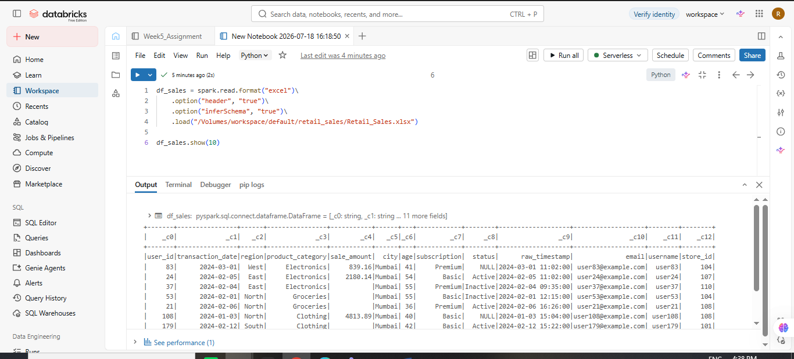

Q1: What are the key limitations of traditional MapReduce that make Spark a preferred choice for modern big data processing?
Answer
- Writes intermediate results to disk after every stage.
- High disk I/O makes processing slow.
- Poor performance for iterative machine learning algorithms.
- Difficult to write complex multi-stage workflows.
- High latency for interactive analytics.
- Limited APIs compared to Spark.
Advantages of Spark
- In-memory processing
- Faster execution
- Rich APIs (SQL, DataFrames, MLlib)
- Supports streaming and graph processing
Q2: Explain how Spark uses In-Memory Computing to speed up iterative machine learning algorithms compared to disk-based systems.
Answer:
Spark stores intermediate data in RAM (memory) instead of writing it to disk after each operation.
For iterative algorithms like K-Means or Logistic Regression, Spark reads the data once, caches it in memory, and reuses it for multiple iterations. This greatly reduces disk I/O and speeds up execution compared to MapReduce.

Q3: Write a code snippet to remove all duplicate rows from a DataFrame based on a specific set of columns: user_id and transaction_date.
df_unique = df_sales.dropDuplicates(["_c0","_c1"])

df_unique.show()

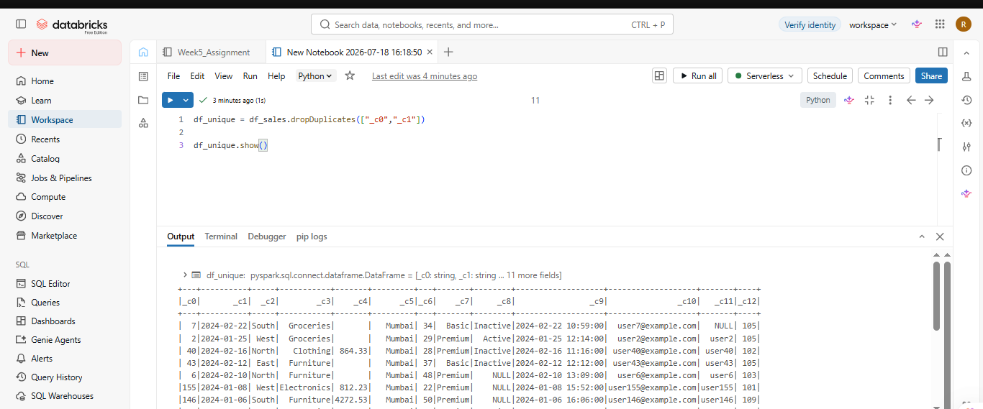
output:

Q4: Given a DataFrame df_sales, write a query to filter for rows where the region is 'West' and then group by product_category to find the average sale_amount.

df_sales.filter(col("_c2")=="West") \
.groupBy("_c3") \
.agg(avg(expr("try_cast(_c4 as double)")).alias("Average_Sale")) \
.show()

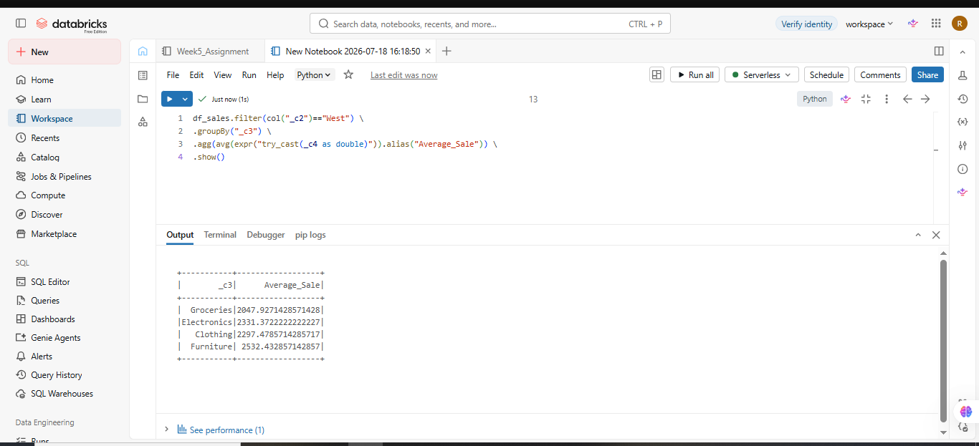
Output:

Q5: What is the difference between .na.drop() and .na.fill()? Provide a code example of filling null values in a status column with the string 'Unknown'.

- na.drop() removes rows containing null values.
- na.fill() replaces null values with specified values.
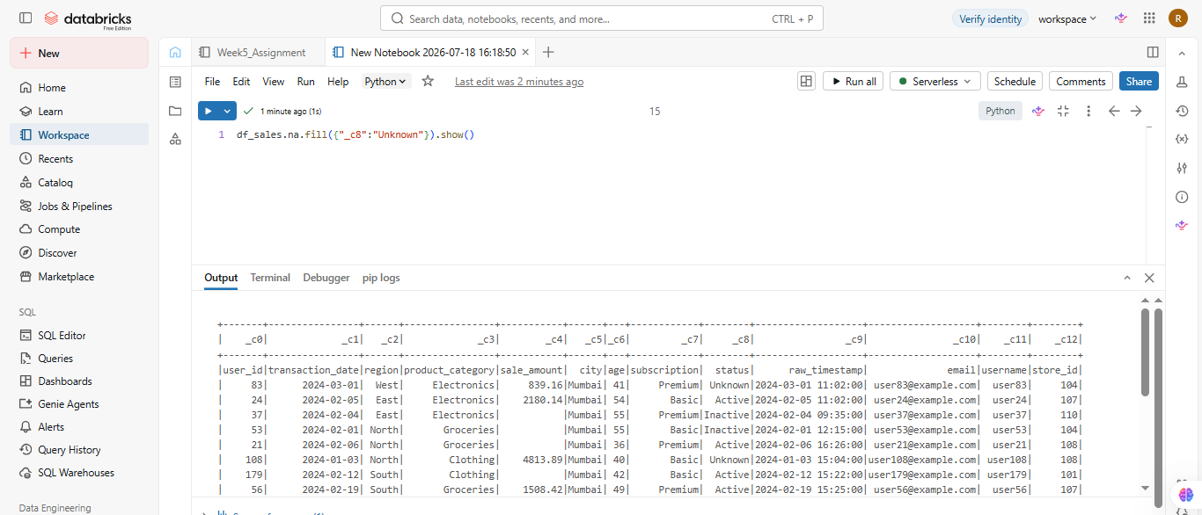

Q6: Write a query to find the total count of records for each city in a DataFrame, but only for cities where the count is greater than 100.
df_sales.groupBy("_c5") \
.count() \
.filter(col("count")>100) \
.show()

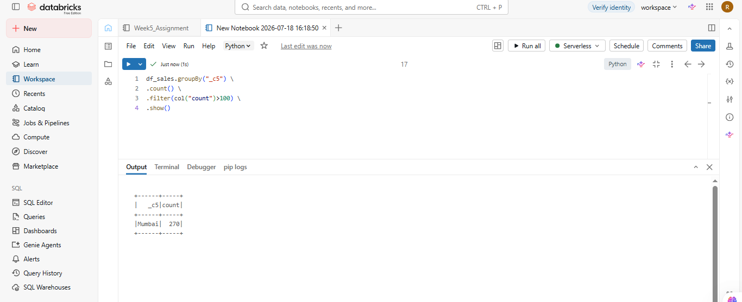
Output:

Q7: How does the immutability of Spark DataFrames affect how you perform "data cleaning" steps like dropping columns or renaming them?
Answer:

Spark DataFrames are immutable, meaning they cannot be changed after creation.

Operations like:

- drop()
- withColumnRenamed()
- filter()

return a new DataFrame rather than modifying the original one.

Q8: Write a Spark command to filter a dataset for rows where the age is between 18 and 30 (inclusive) and the subscription is 'Premium'.

df_sales.filter(
(col("_c6").between(18,30)) &
(col("_c7")=="Premium")
).show()

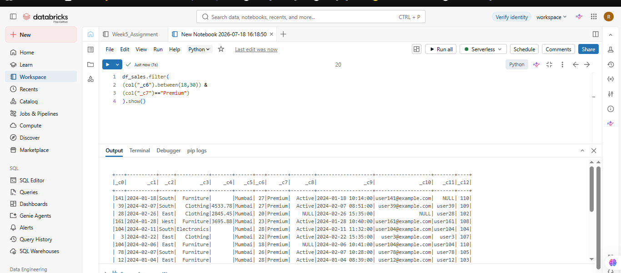
Output:

Q9: When cleaning a dataset, why is it often better to handle null values before performing mathematical aggregations like sum() or avg()?
Answer
Handling null values before aggregation is important because:
- Null values may be ignored in calculations.
- They can produce inaccurate averages or sums.
- Missing values reduce data quality.
- Cleaning data ensures reliable business insights.

Q10: Write the code to revise a column named raw_timestamp by casting it to a TimestampType and renaming it to event_time.
df_sales.filter(col("_c0") != "user_id").withColumn(
"_c9",
col("_c9").cast(TimestampType())
).withColumnRenamed(
"_c9",
"event_time"
).show()

Output:

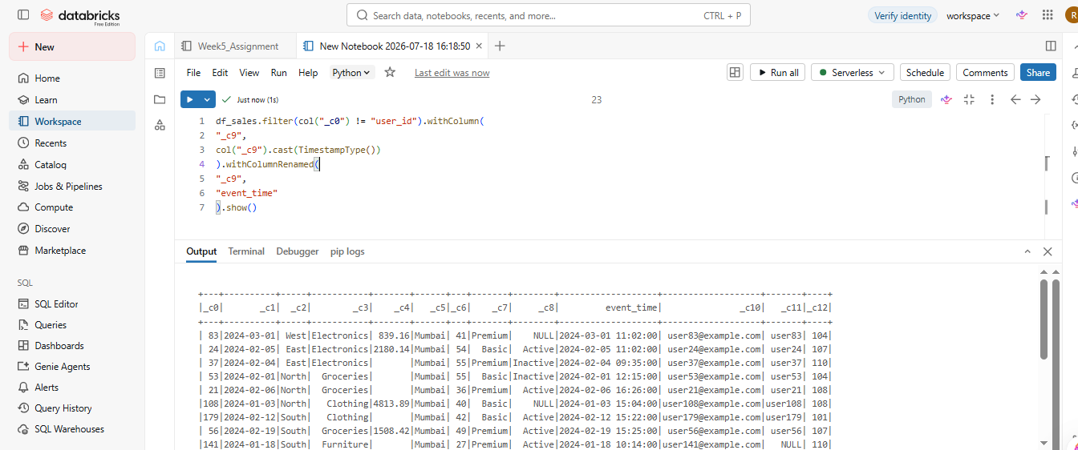

Q11: Explain the "Shuffle" process that occurs during a grouping operation. Why is it considered a wide transformation?
Answer:
A shuffle occurs when Spark redistributes data across different partitions during operations such as:
- groupBy()
- join()
- distinct()
Shuffle is called a wide transformation because each output partition depends on data from multiple input partitions.
It is expensive due to network communication and disk usage.
Q12: Write a code snippet that identifies and removes rows where the email column contains null values OR the username is an empty string.
df_sales.filter(
(col("_c10").isNotNull()) &
(trim(col("_c11"))!="")
).show()

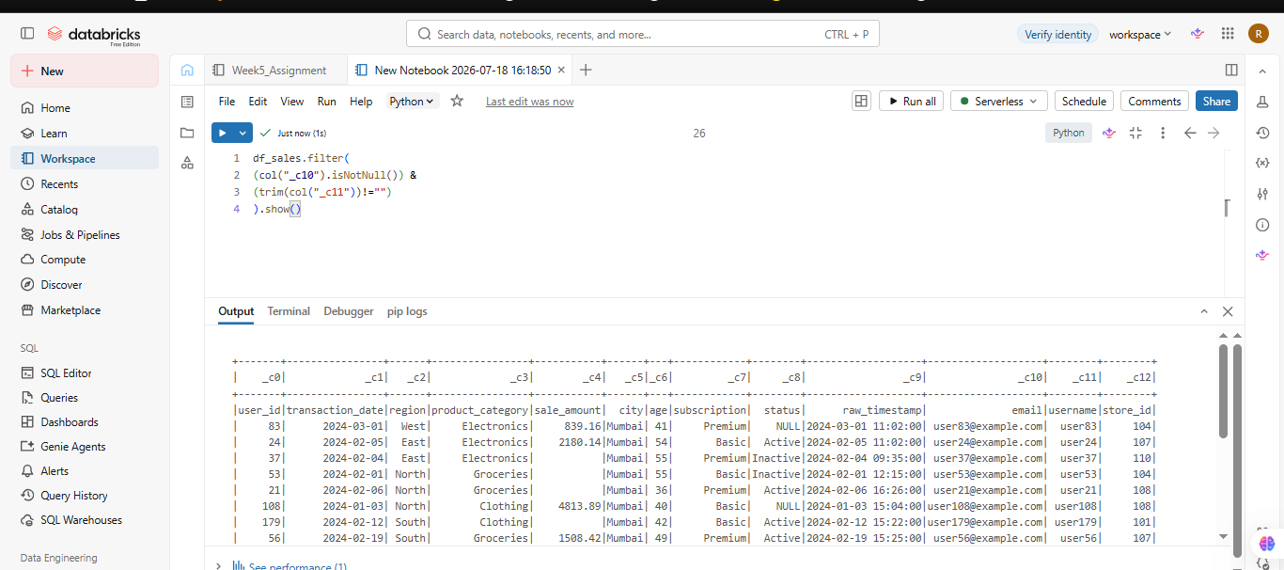
Output:

Q13: How do you use the .agg() function to calculate multiple statistics at once, such as the min, max, and mean of the price column?
df_sales.filter(col("_c0") != "user_id").agg(
min(expr("try_cast(_c4 as double)")).alias("Minimum"),
max(expr("try_cast(_c4 as double)")).alias("Maximum"),
avg(expr("try_cast(_c4 as double)")).alias("Average")
).show()

Output:

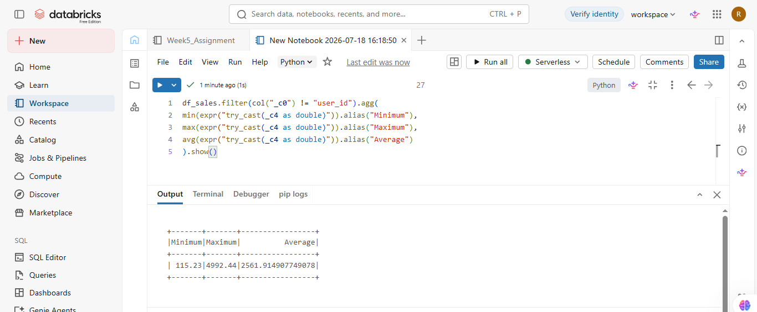
Q14: In the context of cleaning a dataset, what is the risk of using inferSchema=true when your source data contains messy or inconsistent date formats?
Ans:
When source data contains inconsistent date formats, inferSchema=True may:
- Infer the wrong data type.
- Treat dates as strings.
- Produce null values during parsing.
- Cause incorrect query results.
Using an explicit schema is safer for production datasets.

Q15: Write a final processing pipeline that:
- Filters out duplicates.
- Fills null prices with 0.
- Groups by store_id to calculate total revenue.

Output:
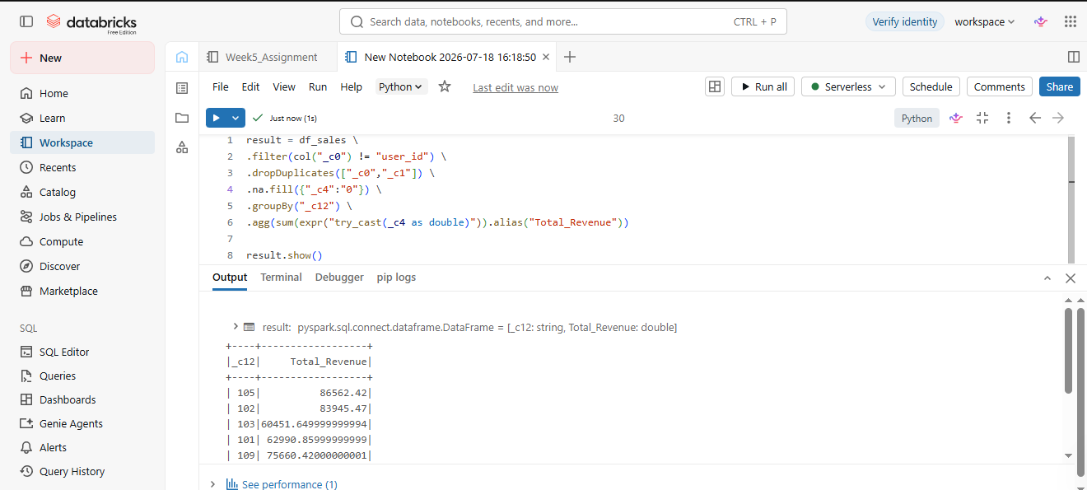
Brief Insights:
- Spark is much faster than MapReduce because it performs in-memory computation.
- Spark DataFrames are immutable, so every transformation creates a new DataFrame.
- Data cleaning (removing duplicates and handling null values) improves data quality.
- Filtering data before aggregation reduces processing time.
- groupBy() and aggregation functions provide useful business insights.
- Shuffle operations are expensive because they transfer data across partitions.
- Explicit schemas are more reliable than inferSchema=True when data is inconsistent.
- An end-to-end Spark pipeline combines data cleaning → transformation → aggregation → analysis efficiently.

Conclusion:
In this Week-5 assignment, Apache Spark DataFrame operations were successfully used to perform data cleaning, transformation, and aggregation. Duplicate records were removed, null values were handled, and filtering operations were applied to improve data quality. Aggregation functions such as count(), sum(), avg(), min(), and max() were used to generate meaningful insights, while groupBy() enabled analysis of data by categories such as product and store.
The assignment also demonstrated important Spark concepts, including DataFrame immutability, schema modification, in-memory computing, and shuffle operations. Compared to traditional MapReduce, Spark provides much faster processing by keeping intermediate data in memory, making it well suited for iterative and large-scale data processing tasks.
Overall, this assignment showed how Spark can efficiently build a complete data processing pipeline—from data cleaning and transformation to aggregation and analysis—making it a powerful framework for modern big data applications.

